Dashboard Report  
1. Top Categories By Total Price :  
  
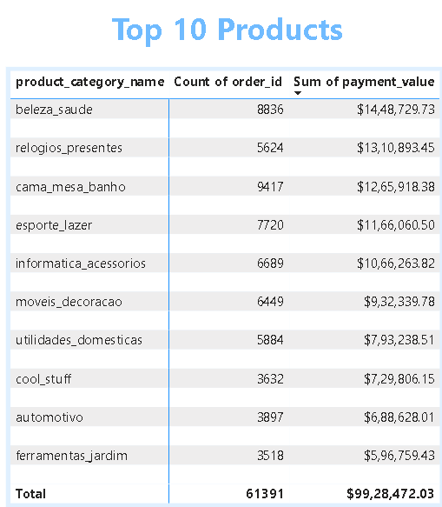  
  
Out of all the categories , the above 10 generate most of the Revenue.   
beleza_saude is generating a revenue of $14,48,729.73 and also has highest number of orders .  
  
2.Delayed order Ananlysis:  
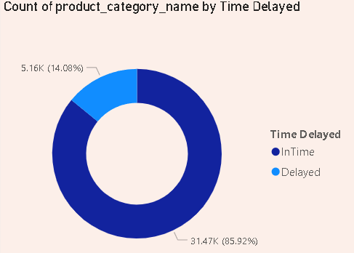  
  
The Highest number of delays occurred in cama mesa banho category.  
Orders delivered on time were 85.92% which is 91,667 orders and the delayed orders are 14.08% which is 7,774 orders.  
  
3.Monthly Comparision on Delayed and On time Orders:  
  
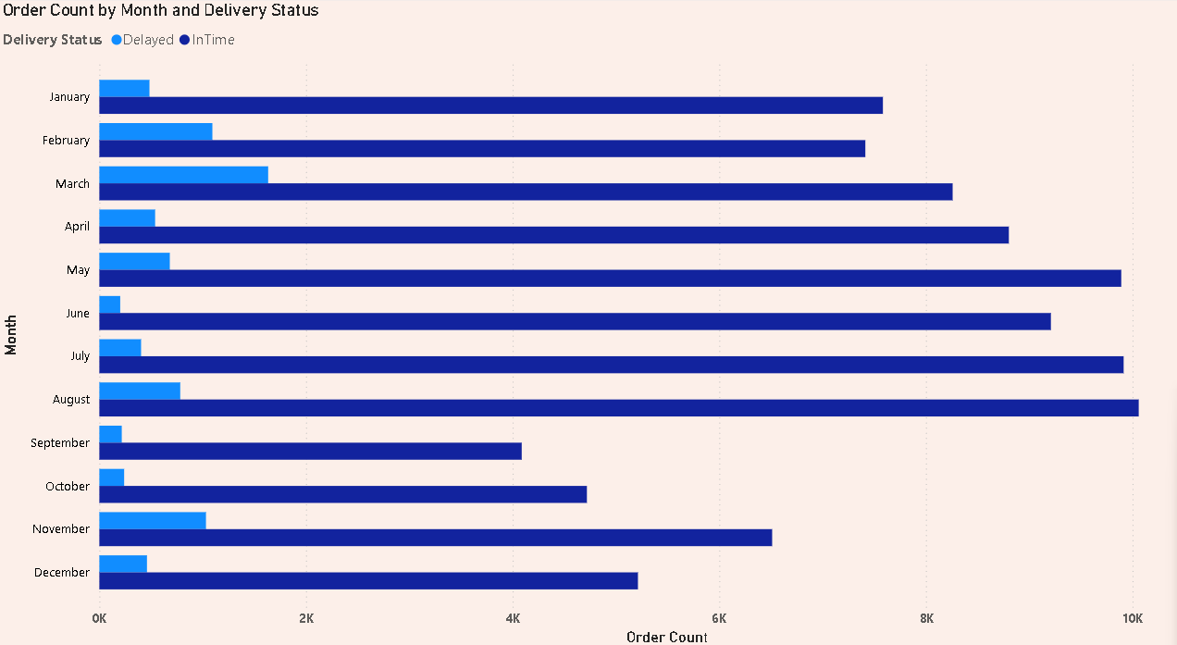  
  
February, March, November months have more delays as compared to others.  
  
4.Payment Method Analysis:  
  
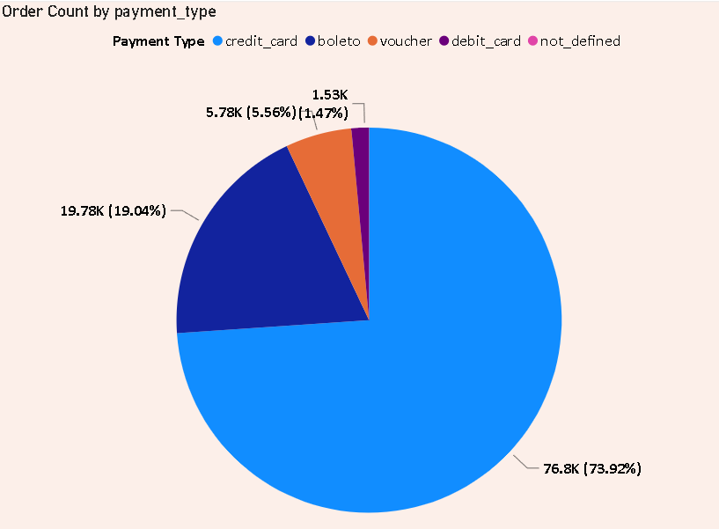  
  
We can observe that people use credit cards to make most of the payments.  
  
5. Product Rating Analysis:  
  
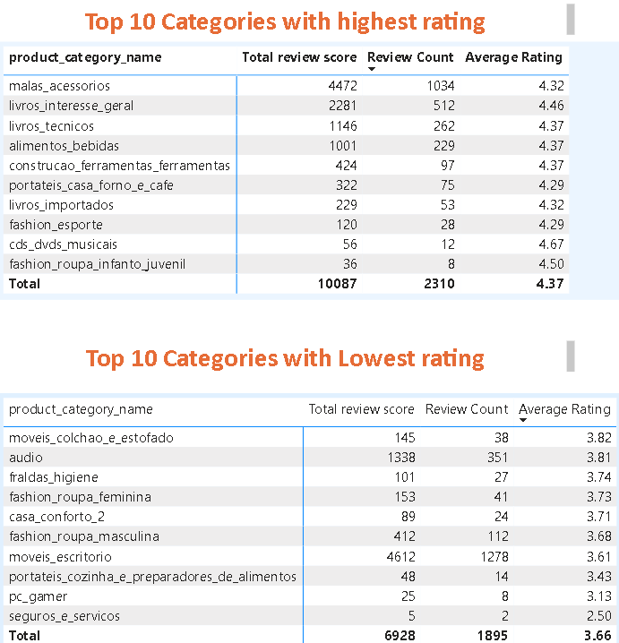  
  
The categories ‘malas_accessorios’ and ‘livros_integresse_geral’ have high review count and still have average rating nearly 4.5 . So this is a great category.

On the contrary ‘seguros_e_servicos’ has only 2 reviews and with average rating of 2.5. We might need to ask them to work on this category.  
  
  
  
  
6.State Wise Sales Analysis:  
  
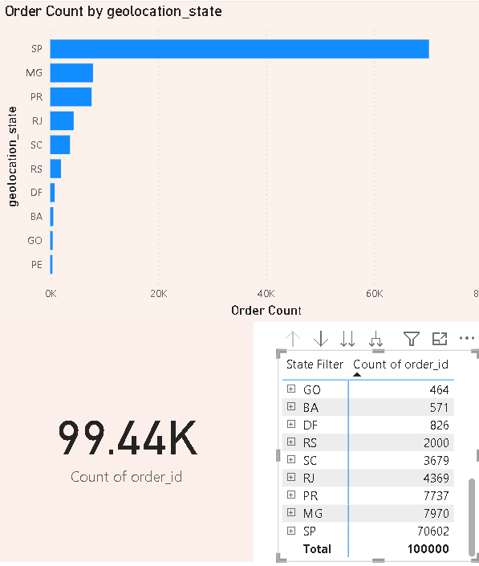  
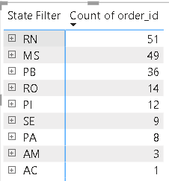  
The major order count was from Sao Paulo with 70,602 orders out of total 100000 orders . However the cities MS,PB,RO,PI,SE,PA,AM,AC have less than 50 orders.  
  
  
7.Seasonal Sales Patterns:  
  
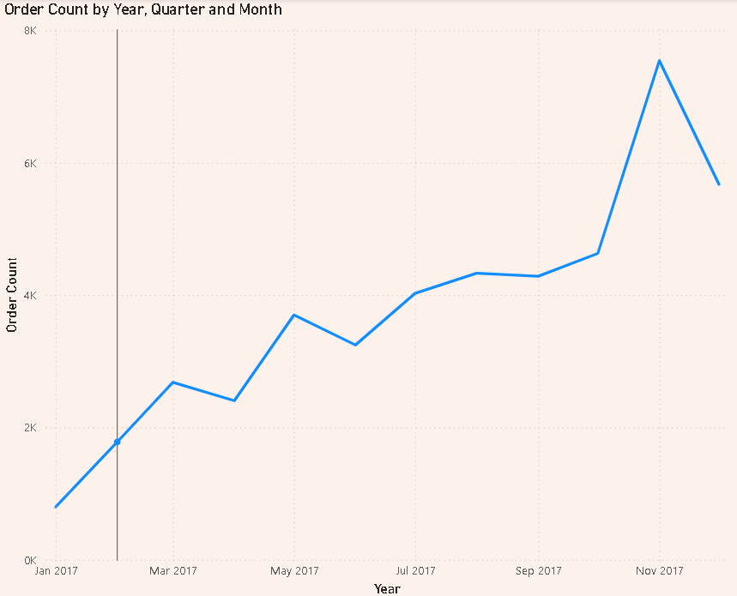  
  
By analyzing the above trend line we can observe that the increase in order count started in January 2017.  
There were fluctuations from March to June but the order count kept on rising in November .  
The peak was in November 2017 with almost order count of 8000.  
But it fell of in December 2017 .  
  
  
  
  
  
  
  
8.Revenue Analysis:  
  
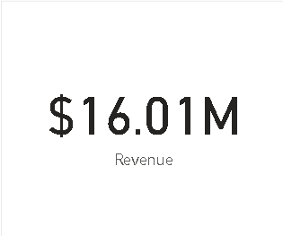  
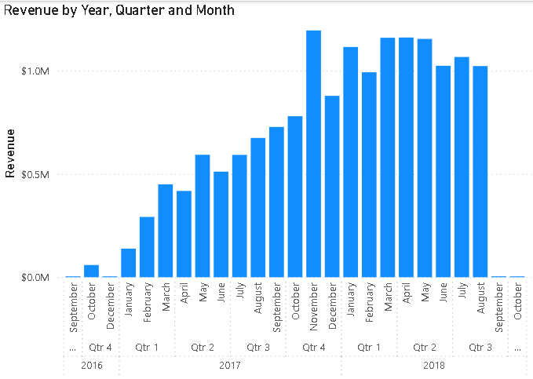  
  
There is a gradual growth in revenue from First Quarter of 2017 to Third Quarter of 2018.  
Mainly in January to August months of 2018 the revenue has crossed over 1 Million every month .  
But it drastically fell after august.